Directions to Accept Federal Subsidized and Unsubsidized Loans
Things to Know:
- Direct Subsidized Loans
  - Direct Subsidized loans are offered to eligible undergraduate students who qualify under financial need.
  - Interest does not start accruing until after the student graduates.
  - The student will not be responsible for making payments until 6 months after the student completes their degree or drops below half-time enrollment.
- Direct Unsubsidized Loans
  - Direct Unsubsidized loans are available, regardless of financial need.
  - Interest begins to accrue upon the receipt of your loan funds.
  - Students are not required to start making payments but can make payments while enrolled in school. However, interest will accumulate and will be added to the principal amount of your loan.

- Log into your ZotAid portal.
- Ensure you are on the correct current academic year. For this example, the student selects “September 2025 - June 2026.”
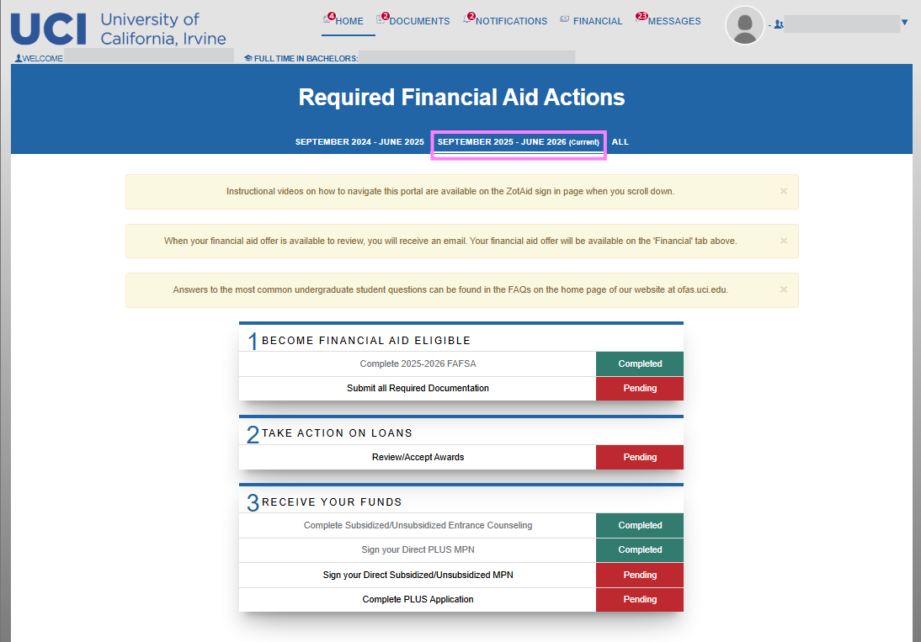

- On the top right, navigate to the “FINANCIAL” tab.

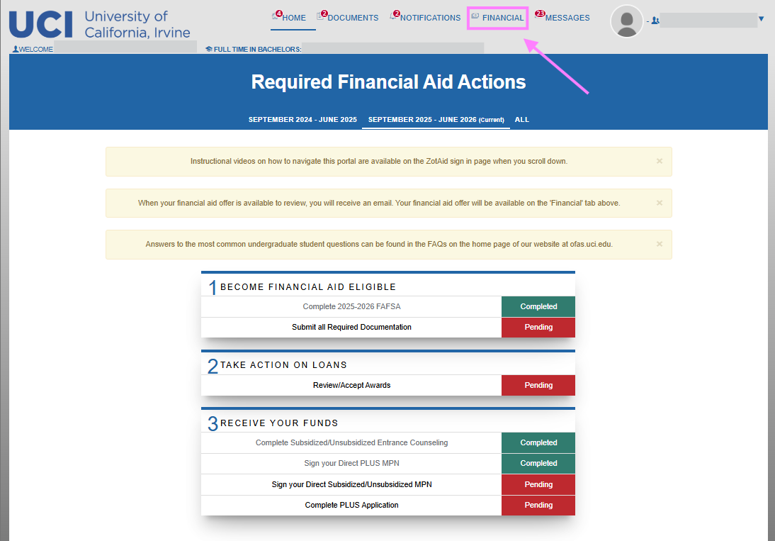
- Under “2. How much Financial Aid can I receive?”, choose the type of loan you want to accept. Select “Update Acceptance.”
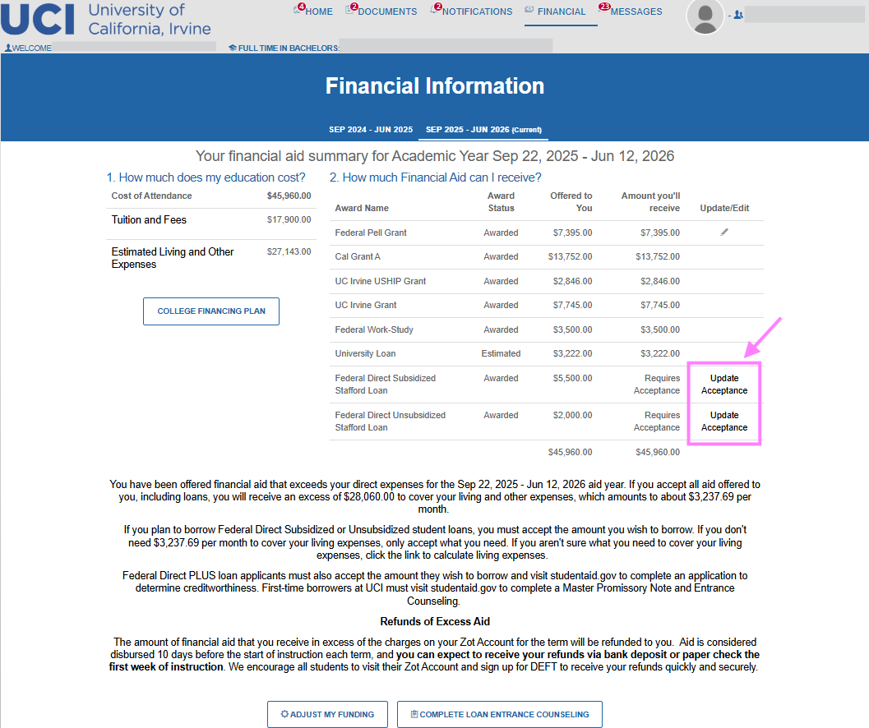

- Loans are accepted by term. Select the quarter you wish to accept loans and unselect the quarters you do not want to “Take Action” on. For this example, the student is accepting loans only for Fall 2025.
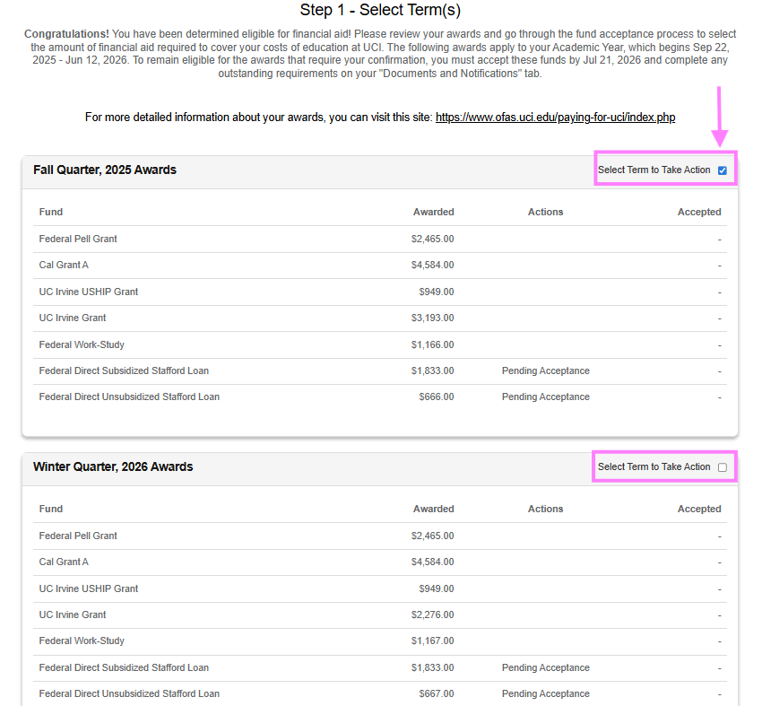

- Continue by selecting “Take Action on Loans” on the bottom right.
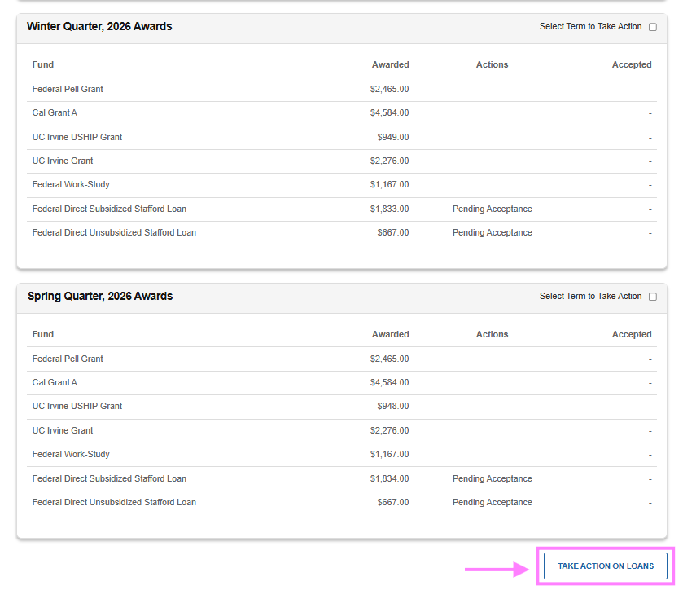

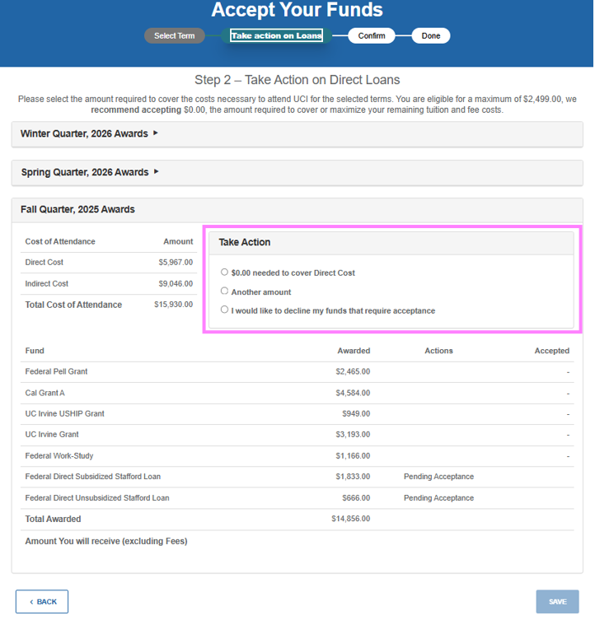
- Students will have 3 options per term. Cover “Direct Cost” (tuition, fees, and on-campus housing only), “Another amount,” or “I would like to decline loans my funds that require acceptance” for that specific term.

- Students cannot accept more than the maximum amount offered for the term. For this example, the student accepts $2,200 of $2,499 offered by inputting this amount in the “Another amount” tab. Select “SAVE” to continue.
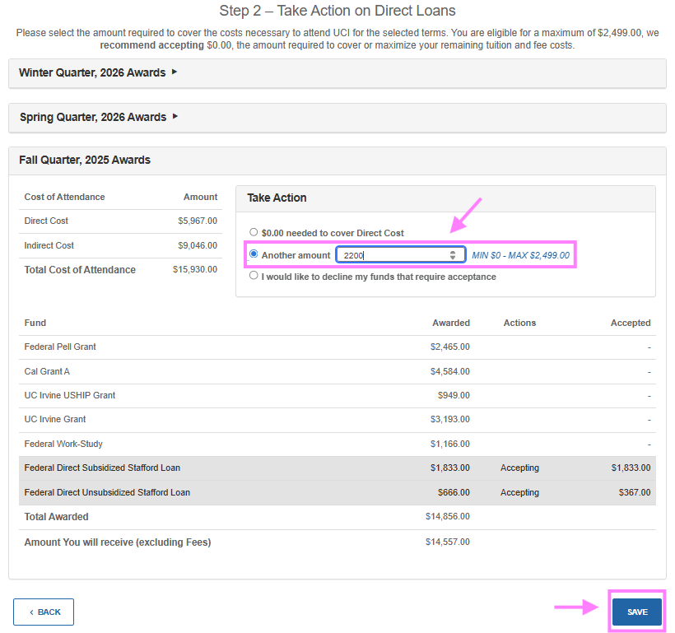
  - *Students who are eligible and qualify to receive Subsidized loans will see the requested loan amount applied to Subsidized loans before Unsubsidized loans.

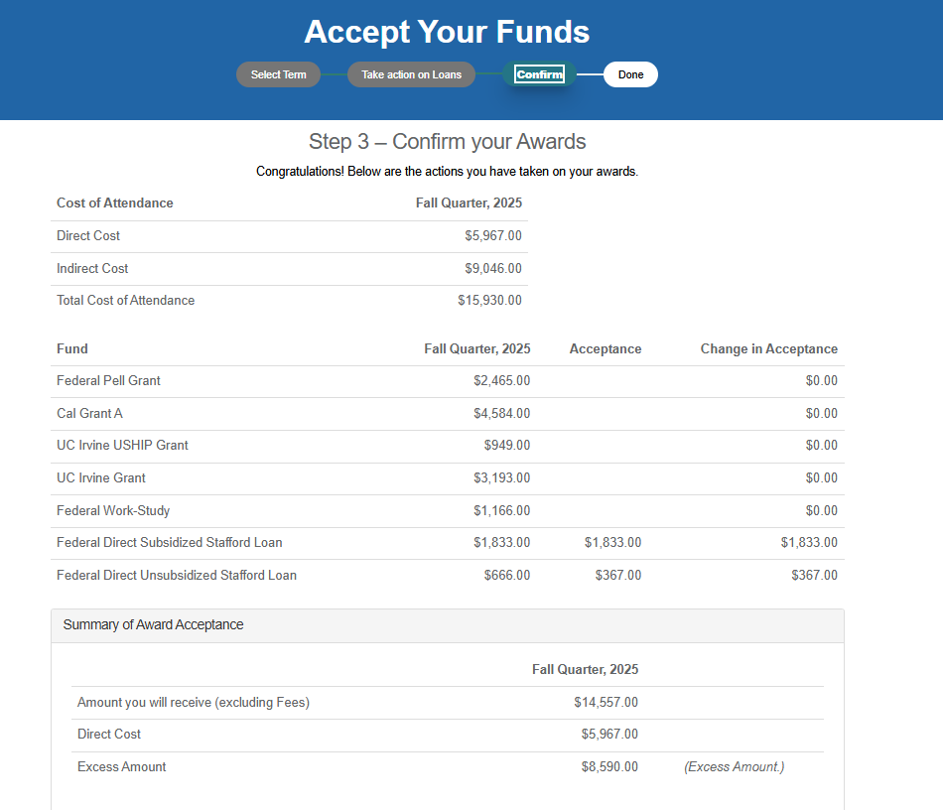
- Step 3 “Confirm your Awards” of the process will show the disbursements per term including their projected refund amount per term (excluding mandatory origination fees).

- To officially accept your loans:
  - Select “I ACCEPT”
  - Enter your Student ID
  - Enter your Last Name
  - Select “Sign & Finish”
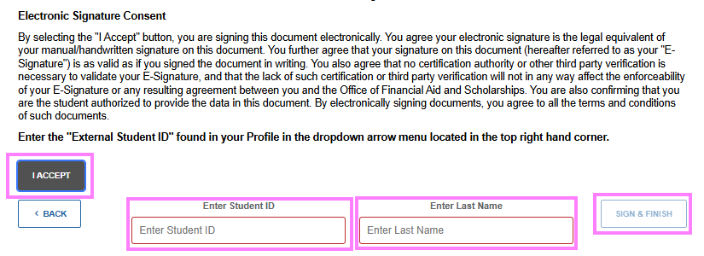
*Upon accepting the loans, students will be required to complete Entrance Counseling and sign the Master Promissory Note.

Directions to Edit Federal Subsidized and Unsubsidized Loans
A student can return to the ZotAid portal to edit their previous action.
- Log into your ZotAid portal.
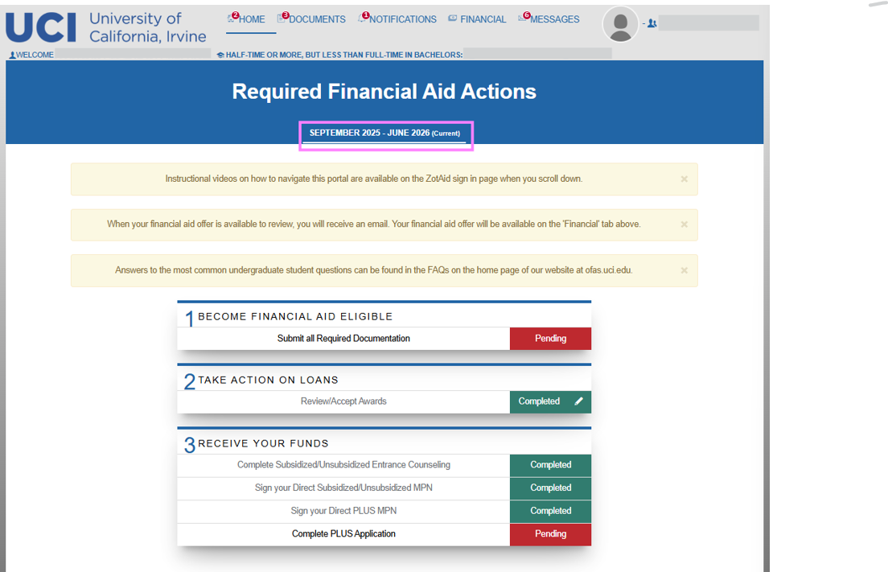
- Ensure you are on the correct current academic year. For this example, the student selects “September 2025 - June 2026.
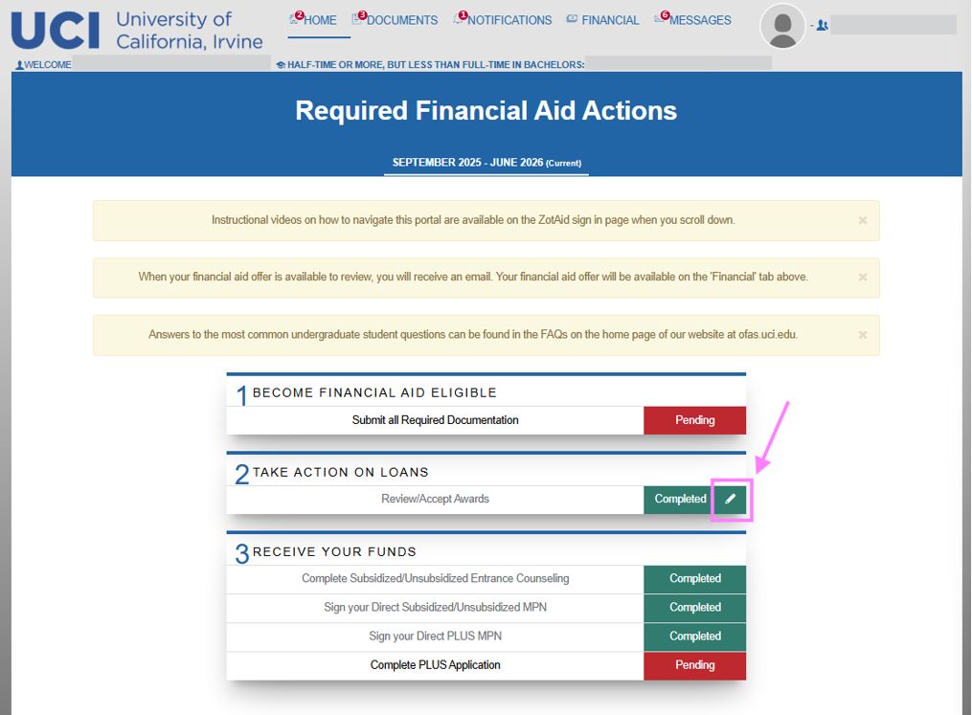
- Under step 2 “TAKE ACTION ON LOANS,” select the pencil on the right corner as seen below.

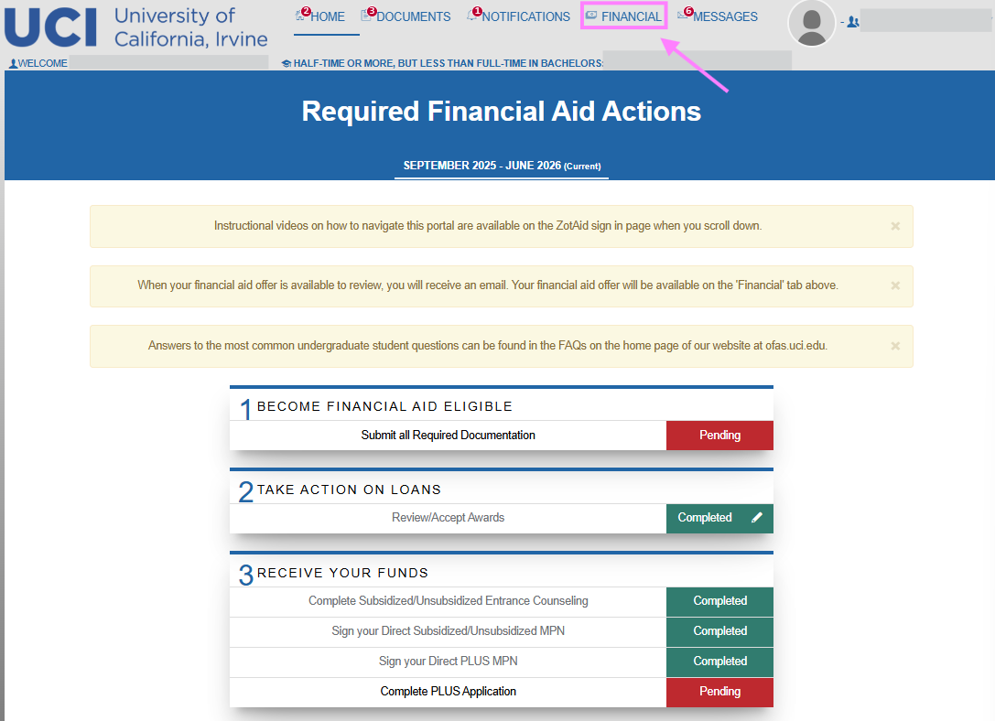
  - If a pencil does not appear upon login, navigate to the “FINANCIAL” tab on the top right of the ZotAid portal.
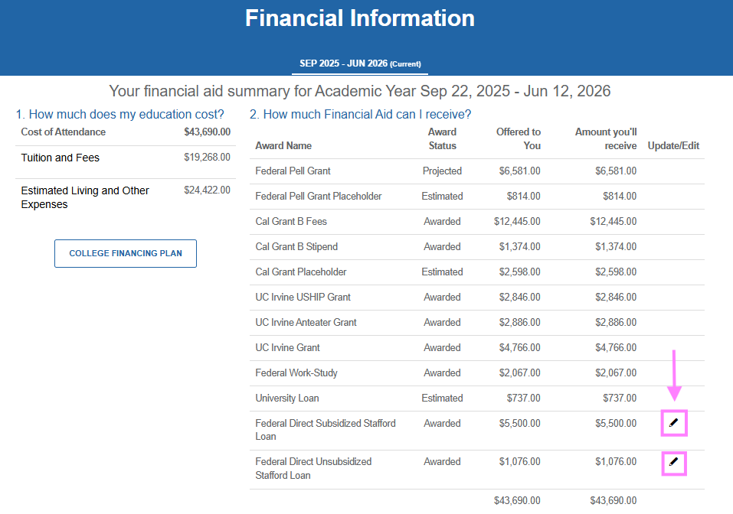
- Under the “Update/Edit” tab, select the pencil to the loan you wish to edit.

- Follow steps starting at step 5 from Accepting Loans

